Joshua Catoe

06/16/18

Quiz 3.1

Team schema:

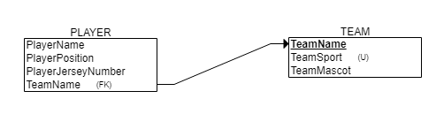

Airline schema:

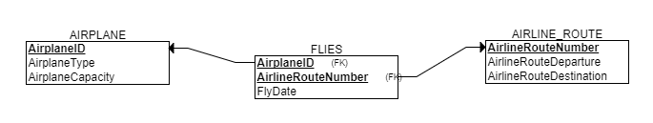

Movie schema:

